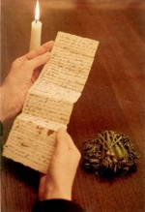
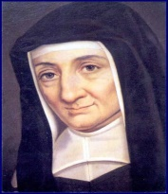

LUMIÈRE

In the year 1623, on the Feast of Saint Monica, God gave me the grace to make a vow of widowhood should He call my husband to Himself.
On the following Feast of the Ascension, I was very disturbed because of the doubt I had as to whether I should leave my husband, as I greatly wanted to do, in order to make good my first vow and to have greater liberty to serve God and my neighbor.
I also doubted my capacity to break the attachment I had for my director which might prevent me from accepting another, during his long absence, as I feared I might be obliged to do.
I also suffered greatly because of the doubt I experienced concerning the immortality of the soul. All these things caused me incredible anguish which lasted from Ascension until Pentecost.
On the Feast of Pentecost during holy Mass or while I was praying in the church, my mind was instantly freed of all doubt.
I was advised that I should remain with my husband and that a time would come when I would be in a position to make vows of poverty, chastity and obedience and that I would be in a small community where others would do the same. I then understood that I would be in a place where I could help my neighbor but I did not understand how this would be possible since there was to be much coming and going.
I was also assured that I should remain at peace concerning my director; that God would give me one whom He seemed to show me. It was repugnant to me to accept him; nevertheless, I acquiesced. It seemed to me that I did not yet have to make this change.
My third doubt was removed by the inner assurance I felt that it was God who was teaching me these things and that, believing there is a God, I should not doubt the rest.
I have always believed that I received this grace from the Blessed Bishop of Geneva because, before his death, I had greatly desired to communicate these trials to him and because since that time, I have had great devotion to him and have received many graces through him. On that occasion, I had a reason for believing this to be so, although I cannot now remember it.

