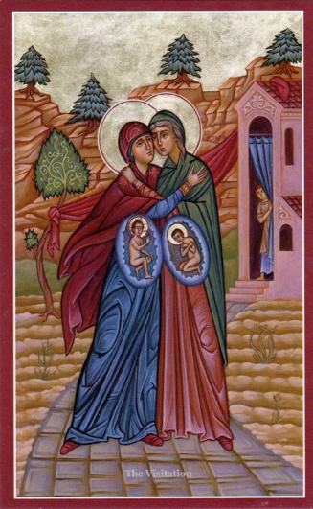

**The Visitation**

**May 31, the Church commemorates and honors**

**the Blessed Virgin Mary’s visitation to**

**St. Elizabeth, the mother of St. John the Baptist.**

**In the Little Company of the Daughters of Charity,**

**this Marian day is significantly dedicated**

**as feast day of the Visitatrices of the**

**Provinces of the Company in the whole world.**

**The VISITATRIX has a mission of animation and governance**

**of a particular Province. She receives from the Company**

**the mission to promote the spiritual and apostolic vitality**

**of the Province. She strives to stimulate,**

**in each community and each Sister, the awareness**

**of their own responsibility in helping the Company**

**to be faithful to its vocation and missionary thrust. (C. 73a)**